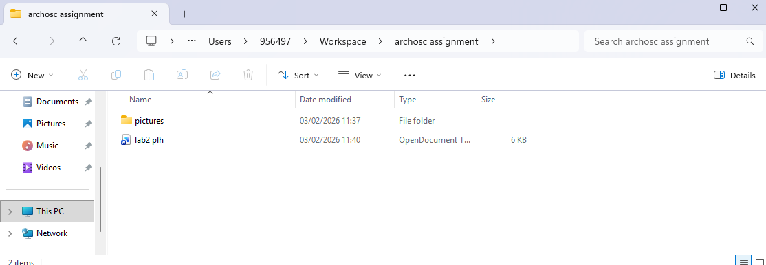
I made a file path from my workspace and took a screenshot of the resulting files, also showing this very document
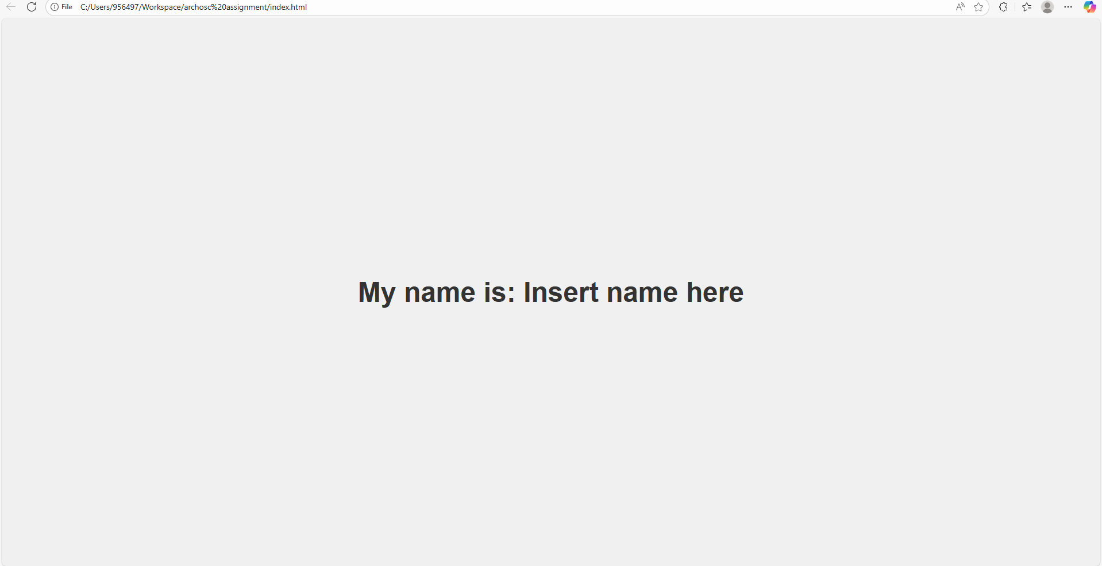
I applied the git repository to the workspace, and made a demonstrative html file
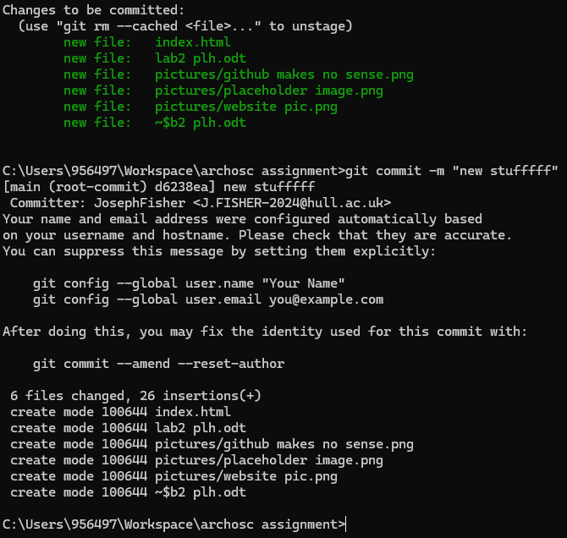
Ive managed to commit a full folder to github through command line, including all above files
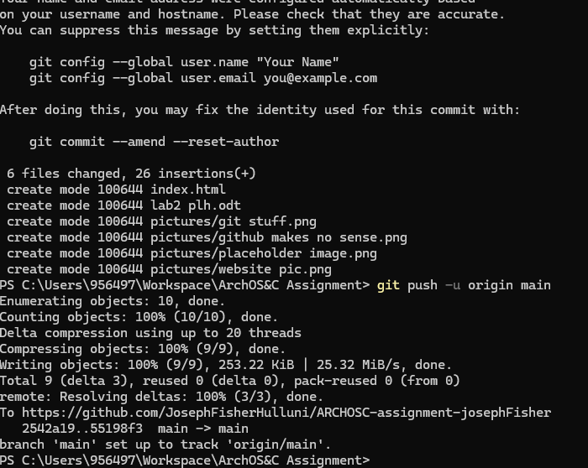
Had to redo some of the github stuff because of a slight misalignment not entirely my fault and also added the git repository
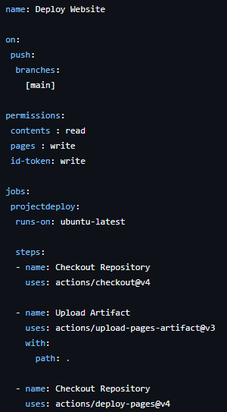
I added yml code to my actions, so every time I push a new version of my repo it runs a virtual machine with linux to deploy any new files

